Contents

Errors 1

Challenges 3

# Errors

Date – 16 Aug 2017

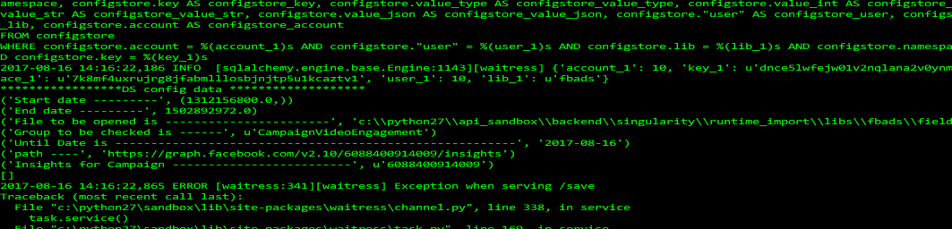

The insights for the video based campaign is not being fetched.

Date – 14 Aug 2017

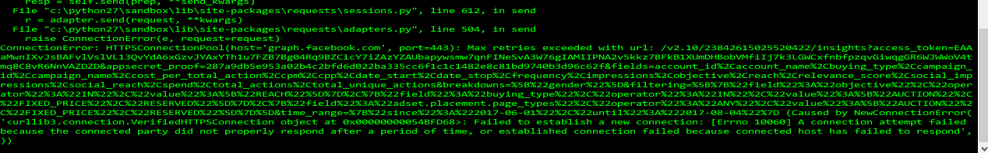

Connection error for FB Link

Date – 14 Aug 2017

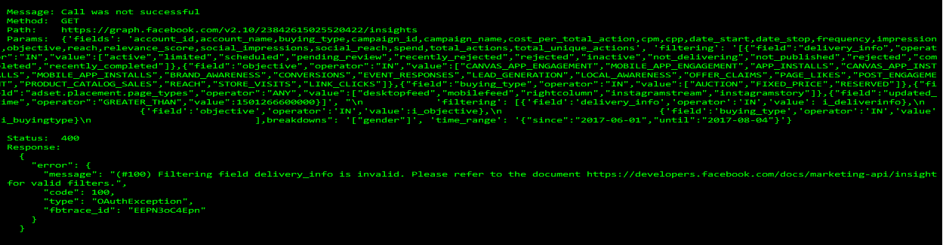

Delivery info sdk tool generated code used – its giving error.

No documentations available for filter objects allowed values

Date – 10 Aug 2017

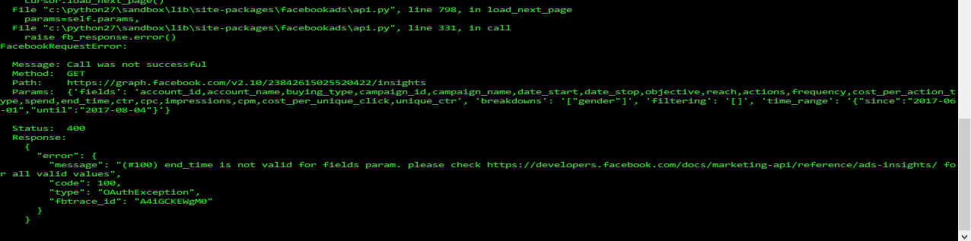

Performance and Clicks – end_time field is giving error therefore removed from the list.

Date – 10 Aug 2017

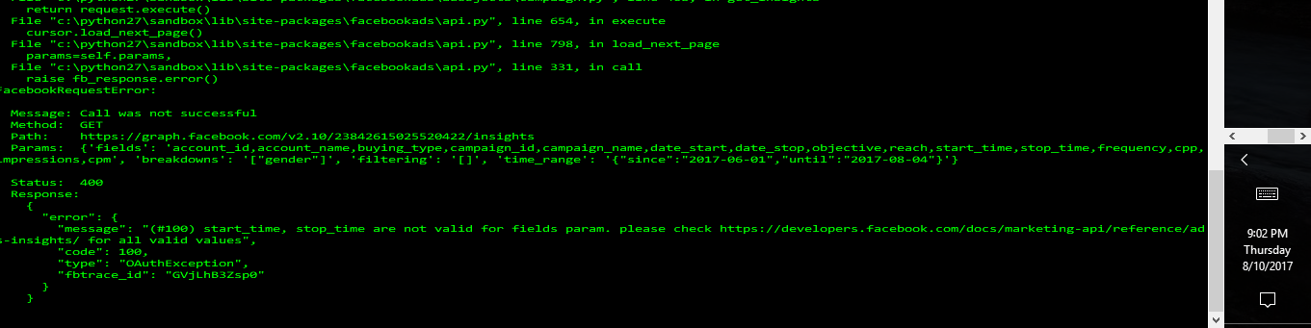

Start_time and stop_time are not valid for fields params.

Removed the fields from the list of fields.

Date – 10 Aug 2017



The highlighted fields cannot be mapped as of now, as similar fields are not found in the field’s link as well as the sdk tool.

If the test data is given then the field names can be tracked back with respective values.

Date – 9 Aug 2017

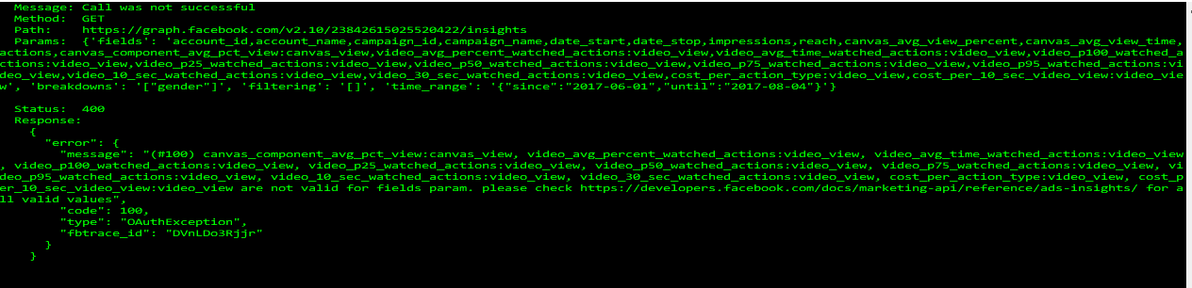

Got this error when videoengagement related fields list was passed to get the get_insights method.

Date – 8 Aug 2017

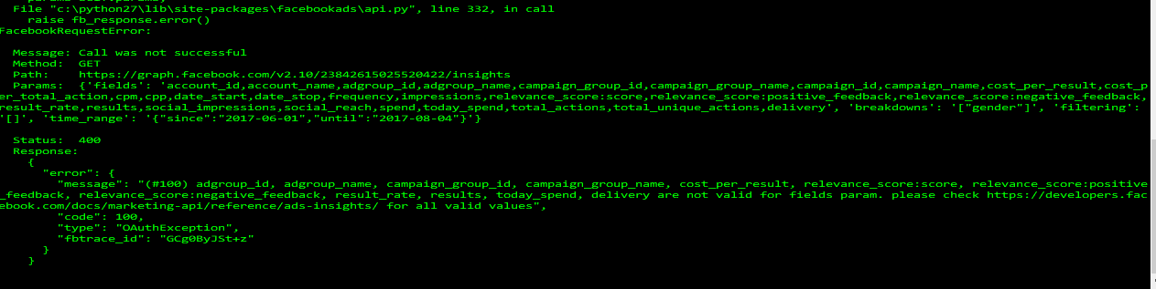

Got this error when the performance related fields list was passed to the get_insights method.

Date – 8 Aug 2017

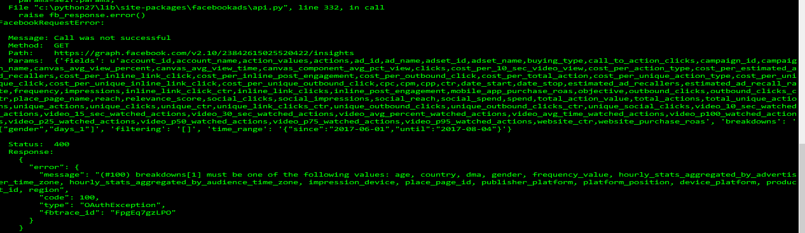

Day wise filtering is not possible. Therefore the data has to be fetched for each day.

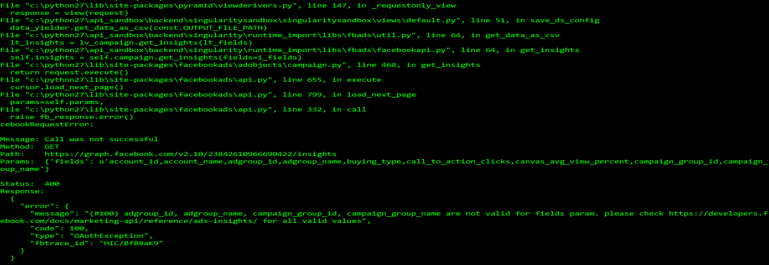

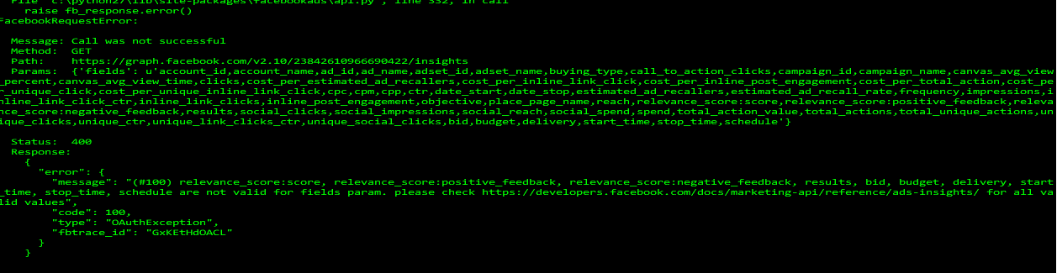

# Challenges

2nd week of Aug 2017 –

Challenges in mapping the fields in respective groups. The field name descriptions in the Facebook Manage Adverts doesn’t match one is to one with the field names mentioned in the SDK Tool and the documentation fields list.

1st week of Aug 2017 –

Challenges in connecting with the Facebook log in. Code which works in the standalone part was giving errors in the sdk.